KEY
Will take you to…………
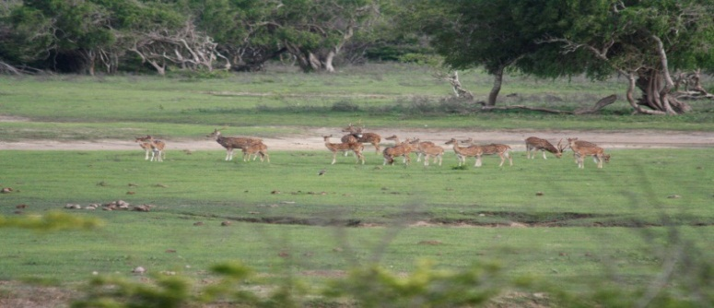
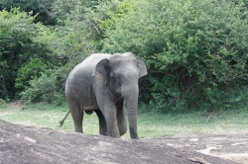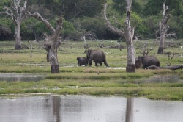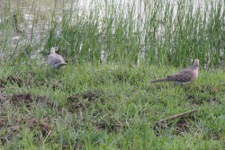
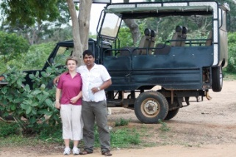 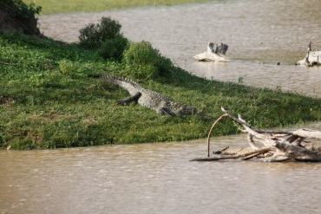 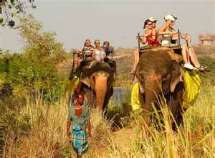 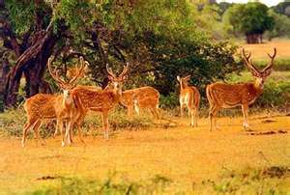 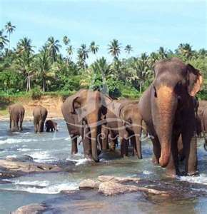 Elephant rides
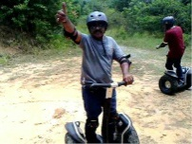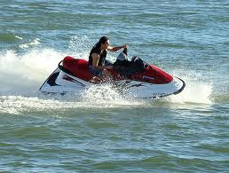
Segway tours, Jet ski riding 4 Weel Gizzle riding
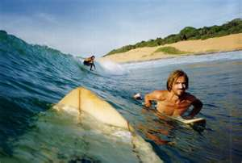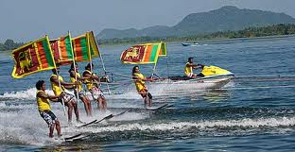
Sri Lanka's east coast where you'll find the unspoilt
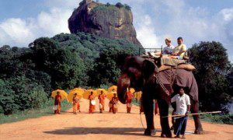 Five reasons why to visit Sri Lanka
- Amazing nature of Sri Lanka – rare and unseen species of plants, interesting wildlife – almost tame squirrels running around the tables, the elephants watching you in the distance.
- An unusually friendly, smiling, and somewhere naive people who are ready, always and everywhere, upon the first request to come to the aid.
- An incredible variety of fruits – some 20 species of bananas, mangoes and other exotic fruits with hard-to say the name, and of course “penny” prices for food and transportation services.
- Interesting program Ayurveda –1.5 hour massage with aromatic oils – many options
- Amazing tour program deep into the island of Sri Lanka, a large number of historical monuments, ranging from 5 century BC.
Sri Lanka – a unique island in the Indian Ocean, located near the southern coast of India, formerly known as Ceylon. Sri Lanka is equipped with everything for an entirely heaven vacation: the azure waters of the ocean, endless sandy beaches, and coconut palms on the shore. For the lovers of active and adventurous tourism the KEY tour organize various excursions with a visit to the unique architectural monuments, Buddhist, Hindu temples, national parks and reserves.

Sri Lanka has a variety of animals spread around the world. Here there are predators: panthers, leopards, wild cats, lynxes, jackals, bears, monkeys. In large rivers are crocodiles having up to 8 meters of length. The variety of the world of birds is just astonishing: pink flamingos, white storks, colorful parrots, colorful peacocks. The symbol of Sri Lanka is world famous Ceylon tea, which is grown in the valleys, protected mountain range from northern winds. The overall picture of this island can be viewed in the craziness of the colors and the varieties- both of them are making you mood upgraded and give you an additional boost of having an awesome vacation here.
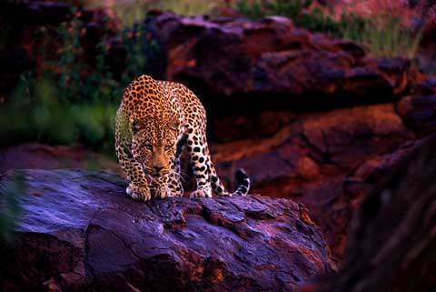
Sri Lanka – one of the most ancient countries in the world and this is not only about the monuments or the legendary conquerors. The thing is that some people believe that this small paradise is actually connected with the Bible Paradise. Somewhere in these parts, according to the legend, Adam and Eve descended to earth. Many ancient authors even point out the location of the Garden of Eden correlated with Taprobanom or Ceylon (until 1972 called Sri Lanka).
Except the legend this amazing island has many historical values protected by UNESCO, as well as a large number of places associated with the name of Buddha. Hundreds of kilometers of beaches and unique underwater world put Sri Lanka in a number of the world’s largest seaside resorts. On this amazing island with rich history and culture can make a very real journey in time to see the pristine nature, national holidays, to learn more about Buddhism, and even be on the edge of the earth – Mount Worlds End. That’s the main reason why some of the artist can this island the beginning and the end of the human world.
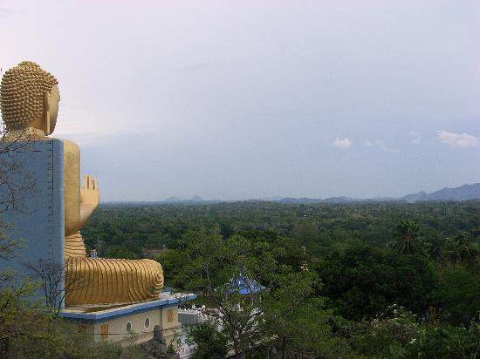
At any time of year, Sri Lanka struck a feeling of eternal summer and a constant riot of rich colors. But this doesn’t mean that weather on the island is as humid and straining as in some parts of India. In the necklace of white reefs the island looks like a pearl on blue velvet of the Indian Ocean. No accident that the great Indian poet and philosopher Rabindranath Tagore called Sri Lanka, “the pearl of the Indian Ocean”, and the Russian writer Chekhov, who visited the island in the early XX century – “a paradise”.
As to the cultural sites in Sri Lanka we might say that it’s one of the best places to get acquainted with the natural and historical monuments which are connected with Buddhism and Buddha. The first ones that come to mind are Adams Peak (2 243) – the holy mountain, a rock with footprints of the Buddha, Temple of the Tooth in Kandy (the tooth of the Buddha), Anuradhapura (ancient royal city of XI), the tree “Bo” (which used to be the tree under which Buddha was resting), Ruvanveliseya Dagobah (a huge ark).
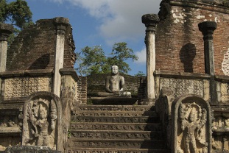
To the lovers of the historical sites and art crafts there are various museums with collections of historical artifacts – in Colombo, Kandy, Ratnapura, Anuradhapura, Galle, and Trincomalee. In Colombo, the most interesting fort (old town), the main political and religious buildings are located – the Presidential Palace and Mosque Yami-ul-AFFA.
The majestic Mount Sigiriya is one of the main attractions of Sri Lanka. Built in the V century on top of the mountain stone castle was a reliable shelter for the king, it was built to protect the kingdom from the conquerors of the islands and the habitants of the continent. After a small rise on the stone steps a gaze of 11 amazing frescoes comes into the view, painted with natural dyes of special composition. On the top of the “lion” rock is still preserved a giant royal throne. All of this is being kept for making the idea of once powerful and undefeatable kingdom.
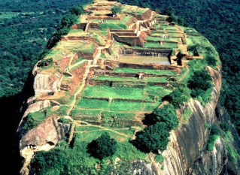
In the city of Polonnaruwa you can witness the ruins of the ancient capital of the Sinhala State. Here you can see the remains of a palace with huge statues of Buddha and the beautiful temple Vatadage. In the northern part of Polonnaruwa is the largest sculptural ensemble in the area – carved into the rocks three huge statues of Buddha. No surprise that this city is truly called a “Buddha Statue Gather Spot”.
Sigiriya (Lion's rock) is an ancient rock fortress and palace ruin situated in the central Matale District of Sri Lanka, surrounded by the remains of an extensive network of gardens, reservoirs, and other structures. A popular tourist destination, Sigiriya is also renowned for its ancient painting.(frescos),which are reminiscent of the Ajanta Caves of India. The Sigiriya was built during the reign of King Kassapa I (AD 477 – 495), and it is one of the seven World Heritage Sites of Sri Lanka.Sigiriya may have been inhabited through prehistoric times. It was used as a rock-shelter mountain monastery from about the 5th century BC, with caves prepared and donated by devotees to the Buddhist Sangha. The garden and palace were built by King Kasyapa. Following King Kasyapa's death, it was again a monastery complex up to about the 14th century, after which it was abandoned. . The Sigiri inscriptions were deciphered by the archaeologist Senarath Paranavithana in his renowned two-volume work, published by Oxford, Sigiri Graffiti. He also wrote the popular book "Story of Sigiriya".
Cave painting inside the ancient Cave temple, Sri Lanka. 5 century
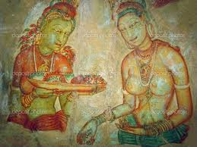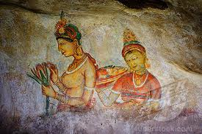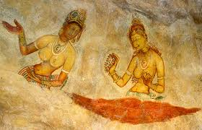
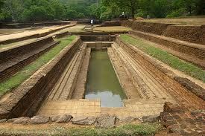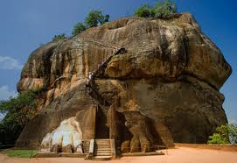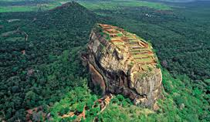

In the suburbs of Kandy – Peradeniya – is Asia’s largest botanical garden with rare palm avenues, with lots of different kinds of tropical vegetation. Here is the tropical flora from around the world.
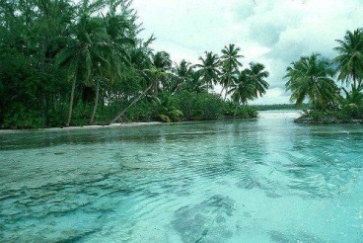
Summarizing we might call Sri Lanka a great mixture of various cultural, historical and natural amazements. Here you can find the representatives of all of three main branches of the religion, but the Buddhism is dominating, you can find both birds and reptiles next to the cute squirrels and of course the mixture of historical monuments and modern hotels.
Located in a beautiful secluded spot with the sea in front and the Hada Oya behind in Arugam Bay.A perfect place to just relax ,the main Arugam Bay stretch is just a 10 minute drive away.

This spot is great for wildlife, elephants visit the land regularly! and it’s a perfect base for visiting Yala East national Park and Kumana bird Santuary (1 and 1 1/2 hour drive) and Lahugala National Park (1/2 hour drive). The archealogical sites of Mudu Maha Viharaya (where Vihara Maha Devi is believed to have landed) is just 15 minutes away, and Magul maha Viharaya (where Kavantissa and Vihara Maha Devi are believed to have got married) and the Kudumbigala Aranya are 45 minutes away.

Location
Wilpattu National Park (Land of Lakes) is located in the dry zone of Sri Lanka. The unique feature of this park is the existence of “Willus” (Natural lakes). The park is located 30km west Anuradhapura and located 26 km north of Puttalam (approximately 180 km north of Colombo). It will take 2 ½ – 3 hours to travel from Colombo.

Experence
Wilpattu is among the top national parks world renowned for its Leopard (Panthera pardus kotiya) population.
The Wild Explorer provides a variety of comprehensive adventure activities including camping, safaris, hiking, exploring the natural habitants of leopards, elephant observation and bird watching.

The WildExplorer Camping Safari schedule
The safari starts on the booked day at 12 noon, meeting point is the Wilpattu National Park entrance gate. You are then taken to camp for a late lunch. Followed by an afternoon safari, you will be back to camp site in time for a relaxing break and dinner under the stars.
Next morning the game drive starts at the crack of dawn so you will see the abundance of wildlife at sunrise. Dawn in the early sunset is the best time to see animals. You are back to camp for a leisurely breakfast, After breakfast again you will be on a safari till lunch time. After lunch we will take you for the afternoon game drive. Camp Fire and BBQ will be arranged for your convenience every evening you stay at the camp site over night.

The safari ends on the day of departure after an early game drive and breakfast, so that you are back at the park entrance before noon.

Rates
Full Board
Number of Pax
Per Person Cost
600 USD
02- 335 USD , 750 USD , 03 , 250 USD , 800 USD , 04 , 200 USD , Every Additional Pax 70 USD , 2 Night /3 Days 12% Discount , 3 Nights / 4 Days or more 15% Discount
Facilities
Well Equipped camping ground is set prior to your arrival.
Spacious tents and friendly customer service.
Comfortable cushioned beds with local hand loomed sheets. Camp site flush Toilets and washing facilities with running water.
Comfortable dining arrangements with tables and chairs, Eastern cuisine with freshly prepared food and beverages would be served, Hearty BBQ, tropical food basket, as requested and any other needs would be attended to.
Chilled beverages will be available during the safaris and camping evening.
Fully illuminated site in the night with traditional type hurricane lamps, characin lamps and camp fires
Experienced courteous & Friendly staff.
Rates include Entrance fees & government Taxes
Holiday in Sri Lanka – Sri Lanka Holiday Tour Packages
\ Select the itinerary/packages you wish and drop us an email. We will get back to you, fast.
Day 1 – Negombo – Anuradhapura
After you got picked up at the airport or your hotel, you will proceed the ancient city of Anuradhapura.
Start the city tour of the city dating back to 3rd century B.C to 10th century A.D. You will visit the Sri Maha Bodhi (the oldest tree in the world with a written history and it is a sapling from the original tree under which Buddha got enlighted), the Brazen Palace, the Ruwanveli Seya Dagoba (biggest dagoba in Sri Lanka), the Thuparama Dagoba (oldest dagoba), the Lankarama Dagoba, the Elephant Pond, the Abhayagiriya Monastery Complex, the world famous Samadhi Buddha Statue and the Isurumuniya Temple (Stone carving of the Sri Lankan Romeo & Juliet)
Overnight at Dambulla.
Day 2 - Polonnaruwa – Sigiriya
Sightseeing of the ancient city of Polonnaruwa (10th-12th century A.D). You will visit the modern museum, the Parakrama Samudra (gigantic reservoir made by king Parakrama the Great), Statue of King Parakrama, the Library Shrine, Palace of King Parakrama, the Kumara Pokuna (pond used by royal family with the water flowing system), the Shiva temple, the Thuparama shrine room with its glittering statues, the Alahana Monastery Complex, the Gal Vihare (a master peace of stone carving), the Lotus Pond and a traditional wood carving factory.
After your afternoon tea you will proceed to Minneriya or Kawudulla Safari. Overnight at Dambulla.
Day 3 – Sigiriya – Dambulla
In the early morning you will have the opportunity to climb the Sigiriya Rock Fortress, built 5th century A.D (claimed by some as the 8th wonder in the world), see the water garden, bolder garden, mural paintings, the mirror wall, the lion’s paws and the royal swimming pool on top. Back to the hotel to have your well deserved breakfast.
After this you will proceed to the Dambulla Cave Temple (built by King Walagamba in the 1st century B.C with 22.000 square feet of ceiling paintings). This is followed by Nalande Gedige (a temple built in the geographical center of Sri Lanka), the spice gardens in Matale and the Aluvihare Cave Temple (this is where Buddhism was brought into book form in the 1st century B.C). Overnight at Dambulla.
Day 4 - Kandy City and Temple of the Tooth
Visit a spice garden in Kandy to see different spices for which Sri Lanka is famous for. Clients will be able to see different spices and how some of these spices are grown and processed. Witness Cookery demonstrations as well.
Kandy, Sri Lanka’s second largest city and cultural capital is the gateway to the higher hills and tea plantations.The clarity of the air and its verdant, hilly outlook around the sacred lake make it a pleasant escape from the heat of the coasts.Followed by a Kandy city tour including the famous Temple of the Tooth and a traditional Kandian Dance performance.
Overnight at Kandy.
Day 5 - The Royal Botanic Gardens Peradeniya.
The Royal Botanic Gardens (Peradeniya botanical garden) is a very popular tourist attraction in Sri Lanka and it’s a paradise for nature lovers. It is located at Peradeniya about 1550 feet above from the sea level, near “Mahaweli River”. The total area of the gardens is about 147 acres. The variation of the clime is very less and the rain fall is about 229 cm per year. The most attractive place in the gardens is the orchid House which has more than 300 varieties of orchids.
After this its off to a gem museum, batik factory. Followed by a Kandy city tour.
Overnight at Kandy.
Day 6 - Kandy to Nuwara Ealiya
After a picturesque drive through Sri Lanka’s hill country you will reach Nuwara Eliya (the so-called Little England) with its colonial hotels, the race course and golf courses. Followed by a visit to the Hakgala Botanical Gardens , Sri Lanka’s highest village.
Overnight at Nuwara Eliya.
Day 7 – Elephant orphanage on way back to Negombo from Nuwara Ealiya.
You will visit the Elephant Orphanage in Pinawella where you can see the feeding of baby elephants by milk bottle and elephants bathing in the river.
Overnight at Negombo.
Day 8 – Negombo to Airport
After breakfast check-out from hotel and proceed to Airport for Departure.

We are small team who love to travel and explore Sri Lanka. We have a range of tours which you can choose based on your need, its totally flexible.

by Aryadasa Ratnasinghe

The open semester to Sri Pada, the holy mountain, began on the ‘Unduvap’ fullmoon day (Dec. 30) and will end on the ‘Vesak’ fullmoon day (May 26) in the ensuing year. This mountain is also known as Samantakuta, Sumanakuta, Samanalakanda, Samanhela, Samangira, Medumhelaya etc. The Christians call the mountain Adam’s Peak, derived from the Portuguese Pico de Adam (Peak of Adam).

This conical mountain is situated 16 km. North-East of Ratnapura, and rises much abruptly from the lower valley than any other mountain in the island. Although it is not the highest mountain, it rises to a trignometrical altitude of 2,243m. (7,360 ft.) above sea level, offering an unobstructed view over land and sea, overlooking the South-central mountain ridges.

The splended view of the tropical wilderness, with its hills, dales and plains, all luxuriantly wooded, bounded by blue mountains, fleecy clouds resting on low ground, and a brilliant sky over-head adds to the panorama of the resplendent island. The charms of the prospects are heightened by the coolness and freshness of the air, and by animation of the scene produced by the singing of birds, in addition to the harsh cries of the wild peacock and the jungle fowl.

From remote antiquity, the visibility of the conical mountain from vessels off-shore to a distance of about 15 km, excited great interest of foreigners, when the island’s interior was unknown to the outside world. It was also the landmark of the sea-faring Arabs, Moors, Greeks and Persians, who came to the island to barter in gems, ivory, spices, elephants etc.

Footprint

The sacred footprint atop the mountain (as most of us have seen) is a superficial hollow of gigantic size, measuring 156 cm. in length, and 76 cm. towards the toes and 71 cm. towards the heel in width. There is the belief that the actual footmark lies on a blue sapphire beneath the huge boulder upon the summit, and what we see is only an enlarged symbolic presentation. The placement of such a huge boulder is attributed to god Visvakarma, who had done so for purpose of protection.

The summit is a small plateau, having an area of 164 sq.m., or 1,776 sq.ft. (74 X 24 ft.), according to measurement taken by Lieut. Malcolm of the British Rifle Regiment, the first European to ascend the mountain in 1816. He had signalled his arrival at the summit by firing three cannon shots from his swivel musket, into the valley below.

The sacred footmark as seen by Dr. John Davy in 1817, was ornamented with a single margin of brass and studded with a few gems. These are now not to be seen. He says, “The cavity of the footmark certainly bears a coarse resemblance to the figure of a human foot but much oversized. Whether it is really an impression is not very flattering, if not for its huge size. There are little raised partitions to represent the interstices between the toes, to make it appear a human foot.”

Robert Knox, the European captive, who spent 20 years (1660-1679), in the Kandyan kingdom, says “The Mountain is at the South end of the Country called Hammalella (Samanhela), but by the Christian People, Adam’s Peak, the highest in the whole island, where, as has been said, is the Print of the Buddou’s foot, which he left on the top of that Mountain in a Rock, from whence he ascended to Heaven. Unto this footstep they give worship, light up Lamps and offer Sacrifices, laying them upon it, as upon a Altar.”

According to the Mahavamsa, the Great Chronicle of the Island, the first person to ascend the holy mountain Sri Pada, was king Vijayabahu I (1058-1114), having come to know that atop the mountain is seen the footmark of the Buddha. It is said that he had gathered this information from the pious woman Manimekhala, who, as a devout Buddhist, was living in South India. Another version is that the king had seen, in the early hours of one morning, angels plucking flowers in his garden. When questioned, one of them had said “We are plucking flowers to worship the footmark of the Buddha atop the Samanalakanda.”
